
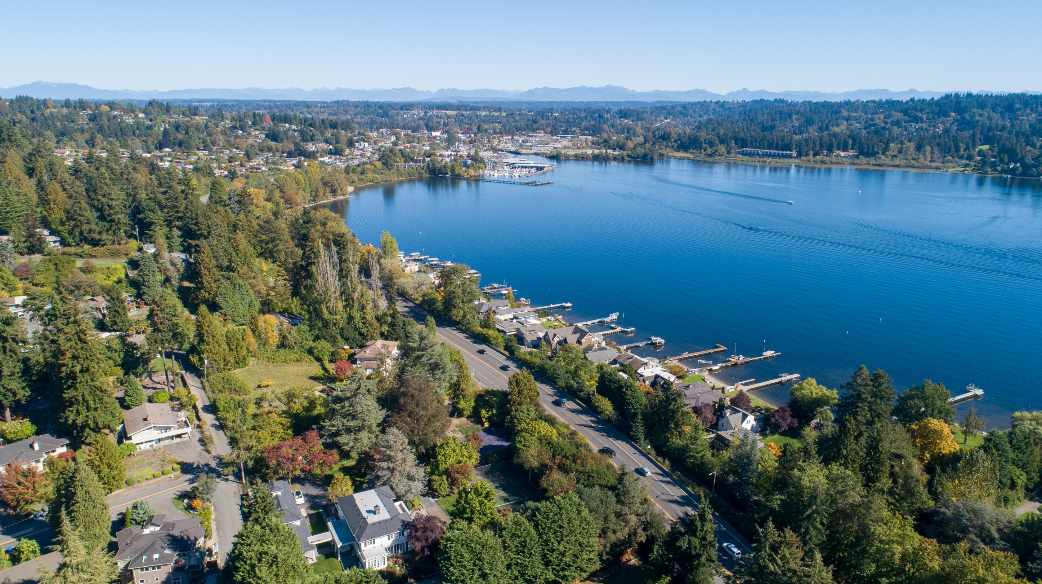
  - City of Lake Forest Park
  - October 2025

Climate Element

Policy Development Memo

Introduction

WA House Bill (HB) 1181
As part of the 2023 amendments to the Washington Growth Management Act (GMA), Washington House Bill (HB) 1181 requires cities and counties to integrate climate policies into their comprehensive plan updates. The City of Lake Forest Park must adopt policy changes that mitigate climate change impacts and enhance resiliency across multiple sectors. These policies must align with the Department of Commerce’s Climate Planning Guidance ​(Growth Management Services, 2023)​.
Table 1. Overview of Climate Element Requirements
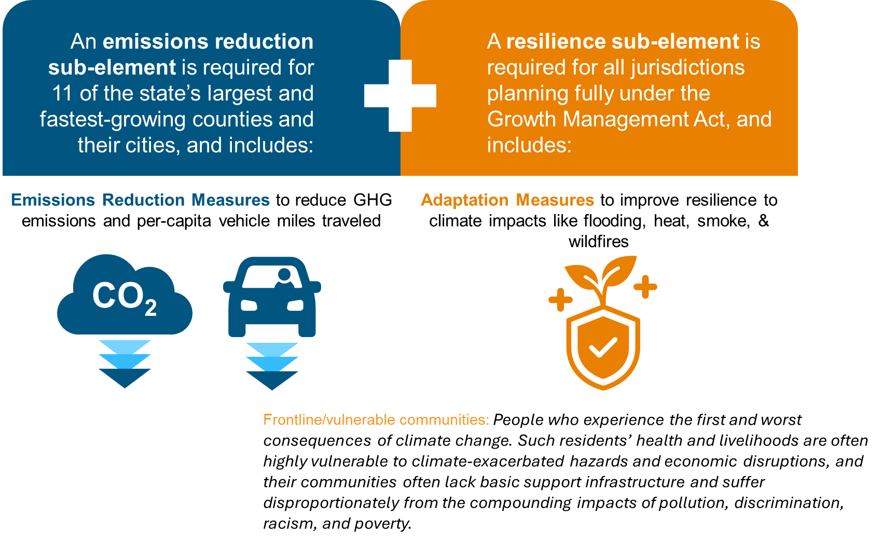

Draft Policies Methodology
The project team followed Department of Commerce guidelines to conduct a policy audit and develop a list of initial draft Climate Element policies for City review. At a high level, we took the following steps:
- Audited core document policies and identified gaps and opportunities. More details are available in the Policy Audit Summary Memo.
- Cross-walked draft policies with several sources:
  - Commerce Menu of Measures
  - City planning documents reviewed as part of the policy audit: Climate Action Plan; Legacy 100-Year Vision Report; Urban Forest Ecosystem Services and Values Report; Parks, Recreation, Open Space, and Trails Plan; Safe Highways Report; and Safe Streets Reports
  - Peer cities in King County
- Met with Drue Epping and Councilmember Tracy Furutani about tree canopy priorities.
- Integrated findings from Vehicle Miles Traveled (VMT analysis), Climate Vulnerability Assessment, and community survey conducted in 2025 as part of the Climate Element development process.
- Integrated feedback from the Climate Policy Advisory Team (2 rounds of review), City staff (1 round of review), and a community open house
- Assessed co-benefits and equity implications of policies; adjusted the language of any policies determined to exacerbate existing inequities.
- Met with the Planning Commission three times between July-September 2025.

Co-benefits Assessment
The following co-benefits were assessed for each policy. These match the list of co-benefits that the Commerce guidance dictates to assess:
- Reduces emissions
- Sequesters carbon
- Enhances resilience
- Improves salmon recovery
- Promotes economic development
- Promotes equity and justice
- Provides cost savings
- Provides ecosystem services
- Protects tribal treaty rights
- Improves public health and well-being
- Improves air quality
- Builds community knowledge
- Protects water quality
- Supports housing supply and diversity

Guide to the Policy Tables
In the next sections, 22 draft Resilience sub-element policies and 24 draft GHG sub-element policies are organized into tables by policy goal.
The sections of each table contain the following information:
- Policy ID = A short numerical identifier for each policy.
- Draft policy language = The full language of each draft policy.
- Source = Documents and other inputs that support inclusion of the policy in the Climate Element. Sources include the Commerce Menu of Measures (stated as CMM in source column), Commerce Guidance Documents, Lake Forest Park planning documents, peer city policies, Vulnerability Assessment, Community Survey, and/or Vehicle Miles Traveled (VMT) Analysis. Any policies that are new (not in the current Comprehensive Plan) are noted as new.
- Rationale = Reasoning for specific language and/or implementation details.
In some cases, our team has recommended editing or removing current Comprehensive Plan policies:
- Any edits to current Comprehensive Plan policies are noted in the policy tables with strikethroughs indicating removed language and bolding indicating added text. In the following example, “and decrease local greenhouse gas emissions” is language our team recommends removing, and “and advocate for clean energy projects in Washington” is text we recommend adding to the policy.
Example: “Participate in regional efforts to create a state-wide clean energy policy and decrease local greenhouse gas emissions and advocate for clean energy projects in Washington.”
- In some cases (in Goal 5), we have recommended removing current Comprehensive Plan policies. These policies are listed directly after the draft policies of the goal which is most relevant, with a rationale for removing each one. In all cases, we propose replacing any removed policies with more specific and detailed policies in the Climate Element.

Resilience Sub-Element
Goal 1. Enhance community resilience to wildfire smoke and extreme heat by strengthening infrastructure, community systems, and natural areas to reduce impacts on residents, workers, and critical services.
ID | Draft Policy | Source | Rationale | Co-benefits
CE1.1 | Integrate cooling low-impact development measures, such as trees, vegetation, permeable pavement, and other heat-resistant infrastructure near high-traffic transportation areas with elevated temperatures. Prioritize tree varieties that are drought- and heat-tolerant and increase biodiversity within the city. | New; Commerce MM Policy T.06; Vulnerability Assessment  Community Survey | Low-impact development measures and heat-resistant infrastructure will protect public health during heat waves and hot days, as well as encourage residents to take alternative modes of transportation.  Improving heat islands at high traffic areas is likely to improve conditions for some overburdened communities.  Policy edited to add sentence prioritizing certain tree varieties after public comment and meeting with Planning Commission. This policy aligns with Policy EQ–8.2: “Develop a tree planting, inventory, and maintenance program for publicly-owned property that considers the species of trees that will be most successful in environments such as public rights-of-way. Pay special attention in the planting program to areas with vulnerable populations.” | Promotes equity and justice, provides cost savings, provides ecosystem services
CE1.2 | Strengthen Lake Forest Park’s critical areas and wildlife habitats by prioritizing natural cooling strategies such as planting shade-providing trees, expanding native vegetation, preserving and restoring wetlands and riparian buffers along creeks, adding shaded water sources, and creating connected habitat corridors to support salmon passage and ecological resilience. | New; Commerce MM Policy U.03; Vulnerability Assessment, Community Survey | Aligns with Commerce requirements to support habitats and aligns with key priorities in the Comprehensive Plan to protect wildlife and habitat. | Improves salmon recovery, provides ecosystem services, improves health and wellbeing
CE1.3 | Partner with local community groups, school districts, libraries, and government agencies to expand access to cooling and clean air resources during extreme heat and wildfire smoke events—especially for low-income households, older adults, people with disabilities, and those with respiratory conditions. Support initiatives such as education on do-it-yourself (DIY) clean air shelters (example, HEPA filter box fans), air conditioner (A/C) and air purifier rebates, cooling kits, and improved infrastructure in public spaces. | New; Commerce MM Policy T.06; Community Survey | Washington has a relatively low rate of AC units in homes, making it essential to find solutions as temperatures rise. Expanding options beyond cooling centers can provide more ways for community members to stay cool. | Promotes equity and justice, improves health and wellbeing, builds community knowledge
CE1.4 | Develop or support public education campaigns to raise awareness of heat risks and connect residents with available resources during heat waves, ensuring widespread distribution through multiple channels such as online, community centers, local events, and multilingual outreach. | New; Commerce MM Policy T.06; Community Survey | Providing information about heat risks and available resources will benefit community health as heat risks increase. Prioritize partnerships with local health jurisdictions, community-based organizations, and regional agencies to educate residents, outdoor workers, and healthcare workers about heat risk. | Builds community knowledge, improves health and wellbeing
CE1.5 | Establish or partner to support resilience hubs that provide cooling, clean air, and essential services during extreme heat, wildfire smoke, and other natural hazard events, and serve as year-round community support and resource centers. | New; CMM Policy T.15 | Extreme heat, wildfire smoke, and other hazards are increasing, especially for vulnerable populations. Resilience hubs offer safe, accessible spaces with clean air, cooling, and essential services during emergencies and provide year-round community support. | Improves health and wellbeing, promotes equity and justice, provides cost savings, builds community knowledge

Goal 2. Advance environmental justice and community well-being by prioritizing equitable climate policies, inclusive decision-making, and access to healthy, resilient environments for all residents.
ID | Draft Policy | Source | Rationale | Co-benefits
CE2.1 | Prioritize neighborhoods facing higher exposure to climate impacts and pollution to receive resilience investments such as increased tree canopy, canopy retention, and green infrastructure, which help mitigate environmental stresses and improve quality of life.  Encourage policies to increase tree canopy cover in socially and economically  disadvantaged neighborhoods. | Current LFP Comp Plan Policy EQ-9.2; Commerce Guidance | Some areas of the City (the very south end, the Town Center Plaza, and more) experience higher than average levels of heat relative to the rest of the city. Focusing on these heat islands can improve health outcomes and improve equity.  Proposed edits tie the policy more closely to climate impacts and broaden the potential green infrastructure investments. | Improves air quality, sequesters carbon, promotes equity and justice, provides ecosystem services
CE2.2 | Consider and promote tracking and Support monitoring the impact the urban forest has on the heat island effect and other of urban forestry’s climate impacts, focusing on high-risk and underserved areas. Protect exceptional trees, expand canopy coverage, and partner with King County’s heat mapping to guide resilience planning. | Current LFP Comp Plan Policy EQ-9.6 | Monitoring provides valuable data to inform future tree planting and maintenance strategies, while protecting historical trees preserves community character, cultural heritage, and environmental benefits.  Edits focus on high-risk (more heat-exposed) and underserved areas and indicate more specific strategies here.  Policy edited to ‘exceptional’ rather than ‘heritage’ trees after public comment and meeting with Planning Commission. | Improves air quality, sequesters carbon, promotes equity and justice, provides ecosystem services
CE2.3 | Support nonprofit organizations that provide education and participation engagement in forest conservation strategies while also prioritizing the protection of natural areas and ecosystems, with a focus on safeguarding local waterways and local salmon species. | Current LFP Comp Plan Policy EQ-9.3 | Partner with organizations such as the Conservation District to enhance the protection and restoration of natural areas and open spaces, recognizing that many parks and open spaces are outside of city ownership and management. Collaborative efforts will help expand the city's reach and reflect community values around nature and open space preservation.  Policy edits reflect community feedback. | Improves salmon recovery, promotes equity and justice, builds community knowledge, provides ecosystem services
CE2.4 | Provide all residents, especially vulnerable populations, an opportunity to learn about climate impacts, influence policy decisions, and co-develop equitable emissions reduction and climate adaptation strategies that reflect community needs and priorities. | Commerce MM Goal AA | Providing equitable opportunities for education, participation, and co-development of solutions builds trust, addresses historical disparities, and leads to more effective and inclusive climate strategies that reflect the priorities and needs of the entire Lake Forest Park community. | Builds community knowledge, promotes equity and justice, reduces emissions

Goal 3. Preserve and protect Lake Forest Park water resources by advancing drought and flood resilience.
ID | Draft Policy | Source | Rationale | Co-benefits
CE3.1 | Integrate water conservation and protection strategies into City planning to address drought, extreme heat, and other climate-related risks impacting water resources in Lake Forest Park. | New; CMM Goal ID# Y; Vulnerability Assessment, Community Survey | Climate change is increasing the frequency and severity of drought and extreme heat, putting added stress on Lake Forest Park’s water resources. Integrating conservation and protection strategies into City planning will help safeguard water supply, maintain ecosystem health, and ensure long-term resilience. | Improves salmon recovery, provides ecosystem services, improves health and wellbeing
CE3.2 | Coordinate with water providers in Lake Forest Park and explore collaboration with the Saving Water Partnership to provide financial incentives such as rebates or tax credits for residents and businesses to install water-saving technologies and systems, including cisterns, drip irrigation, leak detection kits, and smart irrigation controllers. | New; Commerce MM Policy N06, Community Survey | Water conservation supports long-term supply and reduces pressure on local infrastructure. In Lake Forest Park, many homes have irrigated landscapes, and water use peaks in spring and summer when demand is high and supply is limited. Incentives can help residents adopt efficient technologies to manage seasonal demand and build drought resilience. | Provides cost savings
CE3.3 | Promote drought resilience and water efficiency in urban planning through compact development, minimized impervious surfaces, and the use of water-saving design strategies to reduce runoff and promote efficient land use. | New; Climate Action Plan | Conserve water resources, improve groundwater recharge, and mitigate the impacts of drought by reducing runoff and promoting efficient land use when developing new projects, and incorporate these strategies when updating older infrastructure. | Provides cost savings, protects water quality
CE3.4 | Encourage the use of green infrastructure and low-impact development techniques to manage stormwater runoff and flooding, which pollutes waterways and puts community health, infrastructure, and property at risk, amid increasing storm intensities. | Commerce MM Y.03, City staff recommendation | Rain gardens, natural yard care techniques, and other low-impact development tools are all well suited to individual residential properties - and most of Lake Forest Park is low-density residential housing.  Policy edited to add impacts of stormwater runoff and flooding after public comment and meeting with the Planning Commission. | Provides ecosystem services, protects water quality
CE3.5 | Collaborate with local partners to restore floodplains and improve stream and river connectivity as a strategy to reduce flood risk. | New; Commerce MM Policy L.05; Vulnerability Assessment, Community Survey, Climate Action Plan | Restoring floodplains and reconnecting rivers enhances ecological resilience, reduces flood risks, and improves water quality. | Provides ecosystem services, improves salmon recovery, promotes economic development, protects water quality
CE3.6 | Integrate flood resilience into the planning, investment, and maintenance of transportation infrastructure—including roads, sidewalks, trails, parks, and transit—and water infrastructure in Lake Forest Park to reduce future flood risk and ensure these assets remain safe, accessible, and functional during and after flood events. | New; Commerce MM Policy S.01; Vulnerability Assessment | Integrating flood-resilient infrastructure such as improved drainage, raised roadways, and flood-tolerant materials can enhance mobility during heavy rain events. Ensuring that sidewalks and transit stops remain accessible in wet conditions will also support pedestrian safety and public transportation use.  . | Promotes economic development, protects water quality
CE3.7 | Collaborate with water providers to plan and implement resilience measures for critical water infrastructure such as wells and reservoirs in flood-prone areas to reduce vulnerability to flooding and other climate-related hazards. | New; LFP Comp Plan Goal U-4; Vulnerability Assessment | Storm-related flooding, erosion, and landslides can impact Lake Forest Park’s stormwater and sewer systems, as well as power lines and communication infrastructure. Policies that require utility providers to elevate or reinforce infrastructure in flood-prone areas can help maintain essential services during and after major storm events. | Provides cost savings, enhances resilience, protects water quality
CE3.8 | Partner with local agencies, water providers, and community organizations to apply sediment control practices, enhance watershed stability, and support water quality and storage. | New; Commerce MM Policy L.07; Vulnerability Assessment | Reducing sediment helps protect Lake Forest Park’s drinking water, improve stormwater management, and support watershed health. Local partnerships strengthen climate resilience and safeguard community resources. | Provides ecosystem services, provides cost savings, protects water quality
CE3.9 | Coordinate with land managers and community partners to implement erosion and landslide control techniques—including mulching, native grass seeding, and silt fencing—to stabilize soils and safeguard local waterways. | New; Commerce MM L.07; Vulnerability Assessment | Reducing sediment in stormwater (e.g., rivers) helps protect drinking water quality and makes ecosystems more resilient to wildfire smoke impacts. | Promotes equity and justice, protects water quality
CE3.10 | Support inclusive public education and outreach programs on flood risk and water conservation, prioritizing support for communities in flood-prone areas. | City staff, Community engagement recommendation | Proactive communication to the community about flood risks can help them prepare for them. Education about water conservation enables the community to participate in it. | Promotes equity and justice, builds community knowledge, improves health and wellbeing
Goal 4. Strengthen emergency response systems to climate hazards by improving coordination, infrastructure, and community preparedness.
ID | Draft Policy | Source | Rationale | Co-benefits
CE4.1 | Develop a comprehensive waste management plan to address debris removal and waste disposal in post-emergency scenarios, in partnership with local waste services, emergency management agencies, and regional partners. Ensure alignment with the Comprehensive Emergency Management Plan (CEMP). | New, Tree stakeholders meeting | Effective debris and waste management is critical to restoring public safety, health, and infrastructure after emergencies. Coordinating with waste service providers and emergency partners ensures timely, efficient removal and disposal of hazardous and non-hazardous materials, reduces environmental and public health risks, and supports faster community recovery. | Improves health and wellbeing, promotes economic development
CE4.2 | Encourage on-site energy storage and backup systems for neighborhoods in homes and, businesses, and municipal buildings, while ensuring that resilience strategies provide equitable access for low-income households, seniors, and others at higher risk during power outages. | Current LFP Comp Plan Policy EQ-9.5, Climate Action Plan | On-site energy storage and backup systems improve energy reliability during outages, support emergency preparedness, and help reduce strain on the grid during peak demand or disasters.  Policy edits recommend a neighborhood scale for back-up energy, include municipal buildings, and recognize the need for support for affordability and specific groups at risk during outages. | Promotes equity and justice, improves health and wellbeing, reduces emissions
CE4.3 | Collaborate with the Puget Sound Clean Air Agency (PSCAA) and other regional partners to enhance real-time air quality monitoring and community guidance to protect public health during smoke events, building on existing communication systems and expanding outreach efforts to reach more residents, especially vulnerable populations. | Policy Memo; New; CMM Policy T:05 | On-site energy storage and backup systems improve energy reliability during outages, support emergency preparedness, and help reduce strain on the grid during peak demand or disasters. | Improves health and wellbeing, builds community knowledge
CE4.4 | Coordinate with state and local agencies (example, King County Emergency Management, Public Health – Seattle & King County, first responder agencies, and community-based organizations) to monitor risks such as wildfire and heat, identify risk areas, develop targeted response plans, and ensure equitable access to education, outreach, resources, and recovery assistance. Prioritize clear, proactive communication and access to information before emergencies occur. | New, Commerce MM Goal ID #5 | Have inclusive education programs that better help prepare people for climate hazards, can include something about broad education, as well as target education to vulnerable populations  Policy edited to add language about state agencies and monitoring risks after public comment and meeting with Planning Commission. | Improves health and wellbeing, builds community knowledge
CE4.5 | Take steps to maintain reliability of the power grid to withstand climate-exacerbated extreme weather events, such as by maintaining trees near power lines and promoting underground power lines where feasible. | New | Policy added to address power grid reliability after public comment and meeting with Planning Commission.  This policy aligns with existing Comp Plan policies U-5.3 (“Promote underground utilities to the extent feasible.”) and U-4.6 (“Coordinate tree removal and replacement plans with electric utilities to maintain power lines.”) | Improves health and wellbeing

Greenhouse Gas (GHG) Emissions Reduction Sub-Element
Goal 5. Reduce emissions from buildings by supporting low-carbon building energy sources and energy efficient building design and retrofits.
ID | Draft Policy | Source | Rationale | Co-benefits
CE5.1 | Encourage adoption of a standard for sustainability, environmental design, and energy conservation in public buildings. | Current LFP Comp Plan Policy CF-4.11; Commerce MM E.07; Climate Action Plan, Community Survey | The City could provide structural and financial incentives (e.g., density bonuses and tax credits) to developers to certify projects under a third-party standard (e.g., LEED). | Improves air quality, promotes economic development, enhances resilience, provides cost savings
CE5.2 | Implement renewable energy sources and reduce energy use and potable water consumption by City buildings and operations. | Current LFP Comp Plan Policy CF-4.4; Commerce MM E.06 | Electricity and electric heat pumps in public facilities can reduce GHG emissions and help newer technologies become visible for the community. | Enhances resilience, provides cost savings
CE5.3 | Participate in regional efforts to create a state-wide clean energy policy and decrease local greenhouse gas emissions and use the legislative agenda to advocate for clean energy projects in Washington. | Current LFP Comp Plan Policy EQ-5.4 | Collaborate with K4C on this work, which could have impacts that are broader than city limits. The edits to this current Comp Plan policy language note that state-level impact can also occur through clean energy projects in addition to policy. | Improves air quality, promotes economic development
CE5.4 | Work with regional partners and stakeholders to seek and support funding for programs that focus on energy efficiency, clean energy technology, building electrification updates, weatherization, and community solar—emphasizing support for rentals, lower-income households that are currently energy burdened. | New, Commerce Guidance, Climate Action Plan | Collaborate with City Light to educate residents and provide resources, including rebates, to support the transition to more energy-efficient fuels. This will help lower emissions at the residential level. | Reduces emissions, improves health and wellbeing, promotes equity and justice, supports housing supply and diversity
CE5.5 | Build on existing utility-provided energy efficiency and building electrification programs and initiatives through expanding outreach and education programs. Educate residents about incentives for emerging clean energy technology, such as tax exemptions for solar installations., and Increase resident awareness of existing technology such as solar arrays, heat pumps, and other energy efficient home heating/cooling and water heating systems. | New, Climate Action Plan | Build on Seattle City Light's work. https://www.seattle.gov/city-light/residential-services/home-energy-solutions.  Policy edits indicate opportunities to build on existing work and ways to maximize relevance to GHG emissions reduction. | Reduces emissions, provides cost savings, improves air quality, promotes economic development, promotes equity and justice
CE5.6 | Streamline permitting and approval processes for energy efficiency upgrades, building electrification retrofits, and clean energy projects, with the goal of reducing GHG emissions from buildings while maintaining grid affordability, capacity and reliability. | New  GHG Policy Database | Residential and commercial buildings use large amounts of electricity. Jurisdictions can amend building and land use codes to streamline upgrades and retrofits that utilize zero-emission GHG features, reducing GHG emissions and mitigating climate change.  Policy edited to ‘streamline’ rather than ‘support’ after public comment and meeting with Planning Commission. | Provides cost savings, promotes economic development

Goal 5: Current Comprehensive Plan Policies Proposed to Remove and Replace
There are several policies in the current Comprehensive Plan that this team recommends removing from their current chapters and replacing with the proposed Climate Element policies. Specific policies and rationales are below:
ID | Current Comprehensive Plan Policy (Recommended for Removal) | CE Policy Replacement(s) | Rationale for Removing and Replacing the Policy
EQ5.1 | Promote public and private clean energy pilot projects, such as a comprehensive network of electric vehicle charging stations or community solar projects, with the active participation of residents and businesses. | CE5.4, CE7.1, CE5.5 | It is valuable to separate community solar from electric vehicle charging policy. The Climate Element has separate goals and policies to house these topics.  - Policy CE 5.4 supports more types of clean energy projects.  - Policy CE 7.1 adds more detail to electric vehicle charging planning.  - Policy CE5.5 adds details on outreach to encourage active participation.
EQ5.2 | Encourage reduced energy demand, support energy management technology, and encourage greater reliance on sustainable energy sources compared to conventional sources. | CE5.5, CE5.6 | This policy is broad. Policies CE5.5 and CE5.6 contain more detail about how the City can accomplish these goals.
EQ5.5 | Encourage businesses, residents, and new developments to utilize electric or solar energy. | CE5.6 | Policy 5.6 contains more detail about how the City can accomplish these goals.

Goal 6 Reduce driving and enhance alternate transportation options.
ID | Draft Policy | Source | Rationale | Co-benefits
CE6.1 | Prioritize, develop, and maintain mobility hubs in the Town Center and other transportation-efficient locations, especially near overburdened communities that lack sustainable transportation options. | New; Commerce MM I.16, Climate Action Plan | The development of mobility hubs may be incremental upgrades as opportunities arise such as: new or refurbishment of middle and multifamily housing plus commercial development; upgrade of bus stops; utility service work; introduction of electric vehicle charging. | Promotes economic development, improves air quality, promotes equity and justice
CE6.2 | Support expansion of Expand bicycle rack and locker capacity at appropriate transit stops, mobility hubs, and park & rides in a manner that meets Community Protection through Environmental Design guidelines. | Comp Plan Policy T-1.7, VMT Study, Climate Action Plan | This is an enabling policy that should reduce future VMT. | Improves air quality, improves health and wellbeing
CE6.3 | Collaborate with the cities of Shoreline and Kenmore Support collaboration among neighboring cities to provide promote a streamlined, and connected alternative transit options, including a shared-use electric bicycle or scooter program that provides micromobility options across the neighboring provide transportation between cities. | Comp Plan Policy T-2.7, VMT Study | This is an enabling policy that should reduce future VMT.  The edits to this policy broaden the collaboration that can occur and connect the policy more explicitly to VMT reduction. | Improves air quality, improves health and wellbeing
CE6.4 | Develop a connected and complete multimodal network that prioritizes access to key destinations through Lake Forest Park - including the Town Center, transit stations, parks, and trails, and the Town Center - that provides safe access for all ages and abilities. Implement the Safe Streets and Town Center Connections Plans to ensure safe, efficient, and direct pedestrian and bicycle access to the Town Center major community hubs and transit stations. | Comp Plan Policy T1.1, Commerce MM H.03, VMT Study, Community Survey | Develop mode-specific plans, such as bicycle and pedestrian plans, adopt complete streets policies and ordinances, and consider multimodal transportation in neighborhood specific plans.  The policy edit responds to community feedback that there may be locations outside of the Town Center that are worth considering. | Enhances resilience, improves health and wellbeing, improves air quality, promotes equity and justice
CE6.5 | Expand Lake Forest Park's "Safe Routes to School Program" participation, including an education and encouragement component, and continue to apply for local, state, and federal grants to enhance safe routes to schools. | Comp Plan Policy T-2.8, VMT Study, Climate Action Plan | This is an enabling policy that should reduce future VMT. | Enhances resilience, improves health and wellbeing, improves air quality, promotes equity and justice
CE6.6 | Create and support implement outreach and education initiatives and materials that inform the community about transit travel options, in partnership with community groups. | Comp Plan Policy T-3.5, VMT Study | This is an enabling policy that should reduce future VMT.  The edits to this policy emphasize that the City does can leverage and support existing efforts. | Improves air quality, improves health and wellbeing
CE6.7 | Study policy alternatives to reduce vehicle travel, including Explore parking pricing for on-street parking and publicly owned off-street parking based on demand, time of day, and location. | CPAT, VMT Study | This policy complements the enabling policies above to decrease vehicle use and encourage residents to use modes other than single-occupancy driving.  Policy removed after meeting with Planning Commission. | Improves air quality

Goal 7 Facilitate a transition to electric vehicles by expanding charging and education.
ID | Draft Policy | Source | Rationale | Co-benefits
CE7.1 | Align with existing building codes and regulations to draft an electric vehicle (EV) charging plan and sSupport the expansion of electric vehicle charging infrastructure throughout the community, including municipal buildings, multifamily and affordable housing developments, major commercial areas, parking garages, parks, and other community-serving locations to advance transportation decarbonization. | New; Commerce MM Goal AD; Climate Action Plan, Community Survey | Strengthening this policy is crucial given the growing state and countywide support for EV transition and infrastructure.  Policy edited to remove EV charging plan after public comment and meeting with Planning Commission. | Improves air quality, supports housing supply and diversity, promotes equity and justice
CE7.2 | Determine funding sources and establish clear priorities and prioritization criteria to support a phased tTransition of the City fleet to electric vehicles starting with high-use, high-emissions, and cost-inefficient vehicles. | New; Climate Action Plan | This is a complement to communitywide infrastructure. Convert public fleets to zero-emission vehicles by a target date (2035 is stated in the Climate Action Plan) and develop supporting infrastructure and programs (e.g., charging stations and dedicated lanes for electric cars and buses).  Policy edited to remove determining funding sources and establishing priorities after public comment and meeting with Planning Commission. | Improves air quality
CE7.3 | Promote the use of electric off-road equipment in City operations and among community members by providing educational resources, guiding access to available funding or rebate programs, and incorporating electric equipment options into City operations where feasible. | GHG Inventory | Off-road equipment, such as construction and landscaping equipment, will become a larger proportion of GHG emissions as other sources are reduced. Early action to support a transition to electric equipment will have larger effects in the next decades. | Improves air quality, promotes equity and justice

Goal 8. Promote development that advances climate planning, resilience, and greenhouse gas emissions reduction.
ID | Draft Policy | Source | Rationale | Co-benefits
CE8.1 | Foster transit-oriented development by increasing density in areas well-served by transit and prioritize infill development through the zoning and permitting process. | Current LFP Comp Plan Policy LU-4.4; Commerce MM C.06 | Incentivize infill by reducing impact fees and permitting fees, as well as by amending SEPA exemptions to allow residential infill development projects outright. Consider integrating into transportation or neighborhood planning. Also, consider any necessary code changes (zoning, design standards, parking, etc.) and develop incentives.  Aligns with existing Comp Plan policies LU-4.4 and H-1.6 | Supports housing supply and diversity, enhances resilience, improves health and wellbeing, improves air quality, promotes equity and justice
CE8.2 | Implement Explore opportunities for complementary, mixed land use zoning in low-density residential neighborhoods to promote cycling and walking and to reduce driving. | New; Commerce MM V.11, VMT Study, Community Survey | Creating walkable, accessible communities with mixed-use developments can reduce VMT. The majority of Washington cities, including Lake Forest Park, are zoned single-family and do not allow for commercial uses adjacent or integrated within the residential area. Amending land use regulations to require mixed-use developments can facilitate GHG reductions.  Policy edited to ‘explore’ rather than ‘implement’ and to remove language about low density residential neighborhoods after public comment and meeting with Planning Commission. | Supports housing supply and diversity, enhances resilience, improves health and wellbeing, improves air quality
CE8.3 | Reduce parking minimums near transit-oriented development to encourage sustainable transportation choices, reduce development costs, and improve housing affordability. | New; Commerce MM AC.01 and C.05; VMT Study | This policy, which could be implemented in a development code, could help reduce impervious surfaces that exacerbate stormwater runoff and the urban heat island effect. This policy also could encourage active-transportation (walking, biking, riding transit) alternatives to driving automobiles; this reduces emissions, improves community health, and supports other co-benefits.  Policy removed after public comment and meeting with Planning Commission. | Provides cost savings, improves air quality, improves health and wellbeing, provides ecosystem services, promotes equity and justice
CE8.3 | Support Incentivize developments that utilize use clean energy or reduced energy consumption, including affordable housing and rental units. | Current LFP Comp Plan Policy LU-11.3 | Residential and commercial buildings use large amounts of electricity. Jurisdictions can create incentives for new residential and commercial buildings to utilize zero-emission GHG features, reducing GHG emissions and mitigating climate change.  Policy edits are to strengthen the policy and ensure benefits are shared by lower income and rental communities. | Improves air quality, supports housing supply and diversity

Goal 9. Reduce waste generation and increase recycling
ID | Draft Policy |  | Source |  | Rationale |  |  | Co-benefits
CE9.1 | Set and achieve specific goals around waste generation and periodically measure waste via waste characterization study, in partnership with the City's waste collection service provider. |  | New; Commerce MM X.04 |  | Provides a structured approach to tracking and reducing waste, ensuring measurable sustainability goals are met. |  |  | Improves air quality
CE9.2 | Focus on reducing generation and disposal of high-emissions materials, such as organic waste, via outreach and support for composting at homes and businesses. Consider creating a food rescue and/or food waste prevention technical assistance program to support the state’s goal of 50% food waste reduction by 2030. |  | New; Commerce MM Goal D |  | Prioritizing organic waste helps reduce methane emissions and the city’s overall environmental impact. Prioritizing organic waste and paper helps reduce methane emissions and the city’s overall environmental impact. BUT there is already an education and food waste policy in the EQ chapter of the Comp Plan. |  |  | Builds community knowledge, improves air quality, improves health and wellbeing, enhances resilience, promotes equity and justice
CE9.3 | Facilitate the City’s 70% percent recycling rate goal (as adopted by King County) and expand current recycling efforts, such as the battery recycling program at City Hall. |  | Current LFP Comp Plan Policy EQ-5.6, Climate Action Plan |  | Recycling, particularly food, paper, textile, and metal waste, will reduce GHG emissions. |  |  | Enhances resilience, builds community knowledge
CE9.4 | Incentivize reuse and recycling of construction and demolition waste. |  | Commerce MM D.02 |  | Reusing and recycling existing construction and demolition debris avoids carbon emissions associated with depositing construction waste in landfills. Jurisdictions can incentivize recycling of demolition debris by waiving or reducing fees associated with recycling. |  |  | Builds community knowledge, promotes economic development
CE9.5 | Support equitable outreach and engagement around waste reduction (including reuse and repair), recycling, and composting in partnership with the City's waste collection service provider. |  | New, Commerce MM Goal D, Climate Action Plan |  | Engaging all community members ensures more inclusive and effective waste reduction efforts. |  |  | Builds community knowledge, enhances resilience, promotes equity and justice

