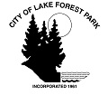

NOTICE OF CANCELATION

NOTICE IS HEREBY GIVEN that the following Lake Forest Park Planning Commission meeting is canceled:

Tuesday June 25, 2019
7:00 – 9:00 p.m.
Lake Forest Park City Hall

The next meeting of the Planning Commission is scheduled for Thursday, July 9, 2019 and will be noticed according to the Open Public Meetings Act.

Dated: June 24, 2019

Posted: June 24, 2019

